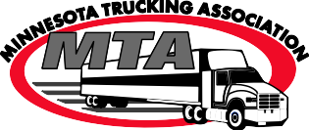







▪



<https://www.youtube.com/watch?v=UpIGgPxhaN8>

▪

▪

▪

▪

▪

▪

▪

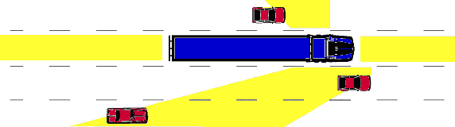



▪



▪

* Distribute a picture of the parking lot to the group beforehand, so that everyone knows what to expect when they get there.
* Each station should do their entire presentation in 8 minutes, that's really hard to do inside the cab, do the best you can there.
* Practice what you're going to say at each station ahead of time, it's much easier if you're not winging it.
* Have some "filler topics" at each station to fill in time if there are delays at another station. These can be truck trivia, further information about trucking (statistics) or even discussions about what they think of the trucking industry as a whole.
* Make it personal, if one person running a station has some specific knowledge in one area of trucking, use that! Play to their strengths when assigning people to each station.

**HOW TO SET UP A BLIND SPOT DEMONSTRATION**

## Demonstration Setup (Diagram 2)

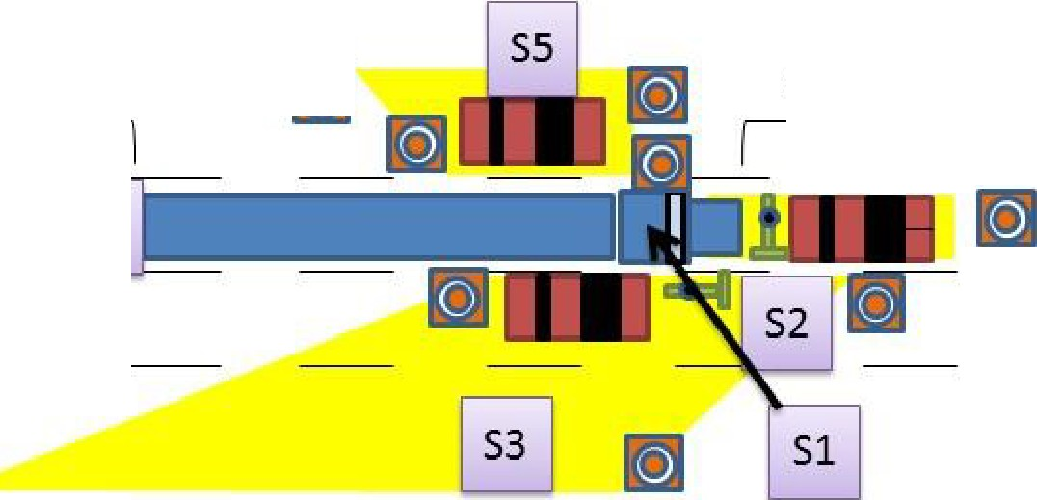

**300 Ft {25 Car Lengths)**

IJ

**320 Ft**

**S4**

**r+l** I **Cone**

I **Car**

I **Bicycle**

B1**Station**

## Space Needed:

* Ideally, 500 feet long by 40 feet wide.
* If you do not have this much space available, other options include:
  + Driver and Passenger blind spots only (70-80 feet long by 30-40 feet wide)
  + Only one side blind spot (70-80 feet long by 20-30 feet wide)

## Vehicles (See Diagram 2):

* Park vehicles in each of the four blind spots (front, driver's side; passenger side and behind the trailer)
* Place bicycles near the front bumper of the tractor, slightly out of the drivers view
* Place cones outlining the 4 blind spots around the truck and trailer
* Place a cone in front of the tractor at 320 feet
* Pull the glad-hand off the service side of the trailer and lock it if possible
* Students will want to blow the horn, have a plan! (drain the air tanks)
* Setup Tip: Place the vehicles and cones using a person sitting in the driver's seat and several people to relay to the person placing the car or cone in place. You DO NOT want to haphazardly place a vehicle for instance so that the student can see the vehicle when they are sitting in the truck.

# SUGGESTED PRESENTATION OUTLINE

**Part 1: Welcome and Discussion Points**

* Introduction of the team, carrier affiliation is unimportant, just say "We are here representing the Minnesota Trucking Association" (Company logo clothing is encouraged).
* Why the trucking industry is essential, give a few facts and basic overview
* How many trucks did you see on your way to school this AM?
* What you buy at Walmart, Caribou, Cub etc. all arrives by truck.
* One in every 16 working Americans is employed by the trucking industry.
* There are 3.5 million truck drivers in the US today.
* Professional truck drivers make an average salary of $44,500.
* You earn more as an entry level truck driver than an entry level pilot.
* 7.4 million people are employed in jobs that are directly related to the trucking industry.
* In Minnesota, **1** in every 18 have a job in the trucking industry.
* 97.3% of carriers have less than 20 trucks in their fleet.
* In Minnesota, 70% of municipalities depend on trucks to provide their goods
* Without trucks, our economy stops.
* Why it is important to share the road
* Trucks are hauling the essential items, such as food, medical supplies, lumber, and clothing, that Americans need in their everyday life. In 24 hours, the US mail service will shut down, within 48 hours, food stocks will be critical.
* You will always need these essentials, it is important that we all learn to share the road, so that these essentials get to where they need to be.
* In 90% of fatal head-on collisions between a large truck and a passenger vehicle, the passenger vehicle crossed the median into the truck's lane of travel.
* Three out of four fatalities involving a car and a truck are unintentionally caused by the car driver.
* The purpose of this program is to educate you to avoid these deadly accidents.
* The size and weight difference between cars and trucks
* A truck and trailer empty weighs 35,000 lbs.
* A typical car weighs between 2,000 and 5,000 lbs.
* A loaded tractor trailer can weigh up to 80,000 lbs, That's the equivalent to the force of 25 cars on impact.
* Define what a Blind Spot is and how that relates to the driver of the truck.

**Other discussion topics may include:**

* Have you ever been in an accident?
* Have you had any interaction with trucks before?
* Do you know where your blind spots are in your car?

# Part 2: Station Breakouts

* Break the groups up into 3 to 8 students and have each group go to a station (See Diagram

2).

# Part 3: Station Demonstrations and Discussion

**Station 1: INSIDE the Tractor Demonstration and Discussion**

* There is no substitute for seeing a tractor from the inside and letting each student sit in the driver's seat and look at the cones in front of and beside them, so that they can see firsthand what the stopping distance and blind spots look like.
* Have a person available outside of the truck to help students both into and out of the cab (Use three-point stance at all times!)
* The "guide" should sit in the passenger seat, first, to allow extra students to the sleeper so they can see that.
* The student should leave the cab with a new perspective of what a truck driver can and cannot see.

**Discussion Points:**

* Point out the cone at 320 feet, that's what it takes for a truck to stop at 55mph.
* Take a few seconds to point out technology in the truck, you don't need to detail it, just point it out. ELD's, Event Recorders etc. That is helpful later on at the other stations.
* A typical truck driver is driving 12 to 15 seconds ahead of themselves down the road.
* Point out the stopping distances out ahead of the vehicle, go over stopping distances.
* At 55 mph, it will take 6 seconds and one football field to stop a loaded truck. (point out that an empty truck will take longer because truck brakes are designed to be at peak performance when loaded).
* If a car cuts in front of the truck inside that space, what happens? (impact)
* Point out the inability for a driver to see the bicycle at the very front of or beside the cab. This ties into crosswalks and being sure that the driver can see them at all times.
* Show the blind spots in the mirrors:
  + Don't linger alongside of a truck. There are four large blind spots around trucks where cars "disappear" from the driver's view and the driver can't see you.
  + Pass quickly to resume visibility and change lanes only when you can see both of the truck's headlights in your rearview mirror. Never pass on the passenger side of a truck, the passenger side blind spot runs the length of the trailer and extends 3 lanes out.
* Mention safety in a crosswalk in front of a truck.
* Let each student have a turn in the driver's seat, pointing out the above talking points to each one while they are in the seat.

## Station 2: In FRONT of the Tractor Demonstration and Discussion

* Never cut in front of a truck. A fully loaded tractor-trailer weighs up to 80,000 pounds and takes the length of a football field to stop.
* Point out the bicycles in front of and beside the tractor and the fact that the driver cannot see them. (blind spots at the cab)
* Stress their actions when walking around a tractor-trailer, these blind spots all come into play even when they are a pedestrian.
* Talk about one of the technologies on the tractor, (ex. lane departure and collision avoidance). Give a brief explanation of what it does and why it's important as a safety feature and promote the idea that trucking is a technology career.
* If they just came out of the cab, ask them what they saw, what surprised them?
* Pass quickly to resume visibility and change lanes only when you can see both of the truck's headlights in your rearview mirror or 4 car lengths.

## Station 3: The RIGHT SIDE of the Trailer Demonstration and Discussion

* Never pass a truck on the right, point out the blind spot, the blind spot extends out three lanes and the length of the trailer.
* Talk about wide right turns and leaving the truck enough room to make the turn.
* Explain what a "right hand squeeze" is and why NOT to do that.
* Don't linger alongside of the truck, stay out of the blind spot completely.
* Talk about ELD's briefly, that they are a means of communication with dispatch for load information as well as a log of the drivers HOS. (don't get too complicated, just say something like "a driver can only work up top 14 hours a day and this ELD allows for it to be tracked accurately").

## Station 4: The BACK of the Trailer Demonstration and Discussion

* Don't linger behind a truck in the blind spot.
* If you are following a truck and you cannot see the driver's face in the truck's side mirror, the truck driver cannot see you.
* You should be able to see driver's mirror when following a tractor-trailer at all times.
* Point out the ICC bar and what it does. When you tailgate a truck, you can't react to upcoming road conditions; you can only react to the back of the truck and often times that's too late.
* If the trailer is equipped with an air dam or side skirts, briefly explain what they do and how they affect fuel efficiency.
* Open the trailer doors and let the students look inside if possible.

## Station 5: The LEFT SIDE of the Trailer Demonstration and Discussion:

* Pass trucks quickly.
* To make themselves visible, cars should not linger near trucks and should move past them or slow down to back off, out of the blind spot.
* Try to leave a 10-car length safety cushion in front of a truck and stay back 20-25 car lengths.
* If you're beside a truck and you can't see the driver's face in the truck's side mirror, the truck driver can't see you.
* Trucks make wide left turns at intersections and require additional space to make those turns, so motorists should allow a truck the space it needs to maneuver.